Full load on table approval-history

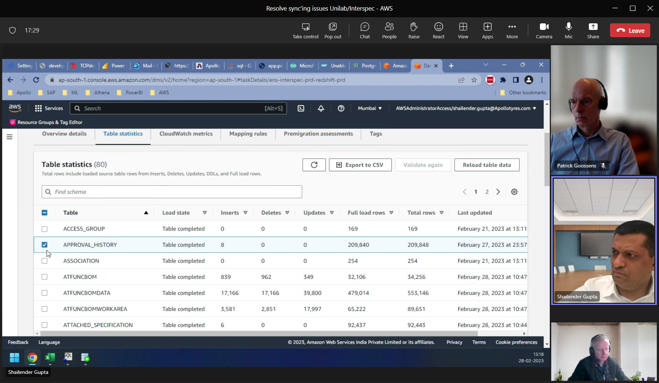

select max(approved_date) from approval_history;

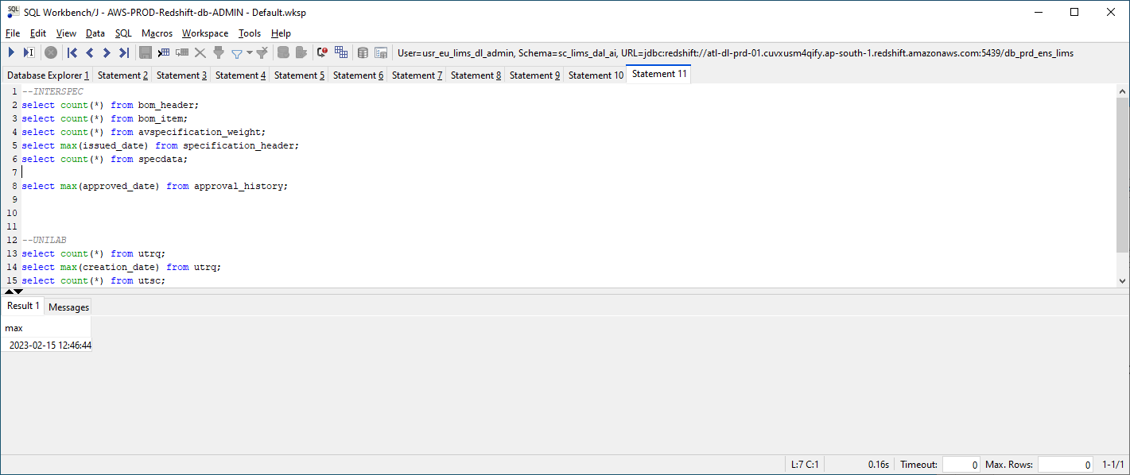

**Agreement dd. 28-02-2023:**-drop all views  
-truncate tables (NOT drop/re-create)  
-grant privileges again  
-create all views / grant views for sc_lims_dal/sc_lims_dal_ai

RESULT:

-full load didn’t fix the inconsistencies. There are still many records missing.

-I didn’t receive confirmation of the full-load, so the VIEWS in SC_LIMS_DAL + SC_LIMS_DAL_AI are not RE-CREATED yet !!!

**Dd 06-03-2023**

Chailender created an AWS-issue for help with the replication-issues.

**dd. 07-03-2023**

All the AWSDWH-sessions on INTERSPEC+UNILAB seems to have restarted this morning !!!  
Yesterday I saw sessions started on the 01-03, todaty all session are from 07/03

Ask Chailender !!

He did nothing !!.